Cairo University  
Faculty of Computers and Information



**CS251**

**Software Engineering I**

Game for all

Software Design

Juniors

Month & Year

Contents

Team 3

Document Purpose and Audience 3

System Models 4

I. Class diagrams 4

Important Algorithm 5

II. Sequence diagrams 5

Class - Sequence Usage Table 8

Ownership Report 9

References 10

Authors 10

# 

# Team

|  |  |  |  |
| --- | --- | --- | --- |
| **ID** | **Name** | **Email** | **Mobile** |
| 20140141 | Sameh Mohamed | [Samehlol16@gmail.com](mailto:Samehlol16@gmail.com) | 01147807779 |
| 20140067 | Emam Mahmoud | [Emammahmoud95@gmail.com](mailto:Emammahmoud95@gmail.com) | 01141483190 |
| 20140091 | Ehab Mostafa | [E7abmostafa@gmail.com](mailto:E7abmostafa@gmail.com) | 01112700405 |
| 20140126 | Roaya Mohsen | [Roaya.mohsen.mohey@gmail.com](mailto:Roaya.mohsen.mohey@gmail.com) | 01149977520 |

# Document Purpose and Audience

**This is a document for educational site that help student to learn with easy way**

**Audience:**

* **CEO**
* **PM**

**GitLab:**

<https://gitlab.com/SamehMohamed/software.git>

# System Models

## I. Class diagrams

| **Class ID** | **Class Name** | **Description & Responsibility** |
| --- | --- | --- |
| 1 | Template | It contains the data of templets which teacher selected it to create new game. |
| 2 | Type | Which contain list of templets to teacher to select the template of his game that he wants to create new game and choose template. |
| 3 | Category | Which contain list of types to teacher to select the type of his game that he wants to create new game and choose type. |
| 4 | Game | Choose category of game to be played or created by user (if student or teacher). |
| 5 | Teacher | Inherent from user and this user who can create new game. |
| 6 | Student | Inherent from user and this user who can play games and have achievement. |
| 7 | User | Which have two types of user (student, teacher) and have the information of every user (name, gender, e-mail, password, age). |
| 8 | Interface | It is interface of the website which connect process between user and system, show (registration, login) forms, show messages, and loading game for user to play. |
| 9 | System | Which connect process between Interface and Model. |
| 10 | Model | It’s the database of the site which have all data about users, games and another data. |

### Important Algorithm

Not Know yet if we use a complex algorithm or not.

## II. Sequence diagram

1. Play Game Sequence diagram

## 

1. Create Game Sequence diagram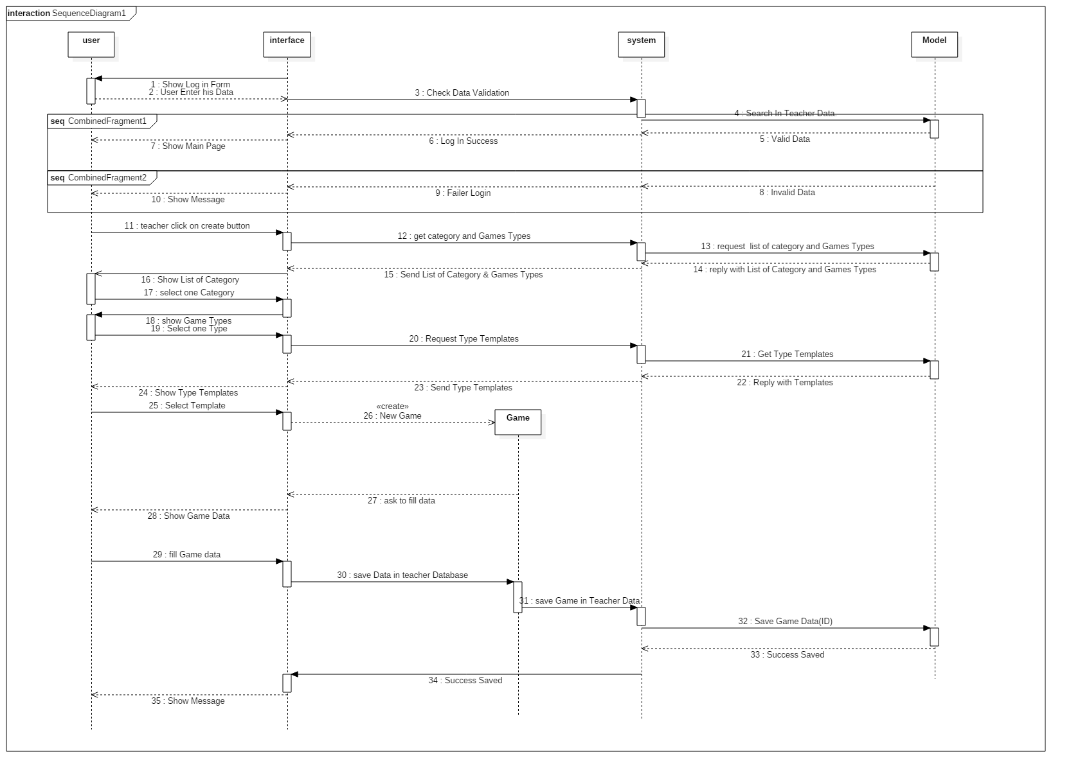3. Registration Sequence diagram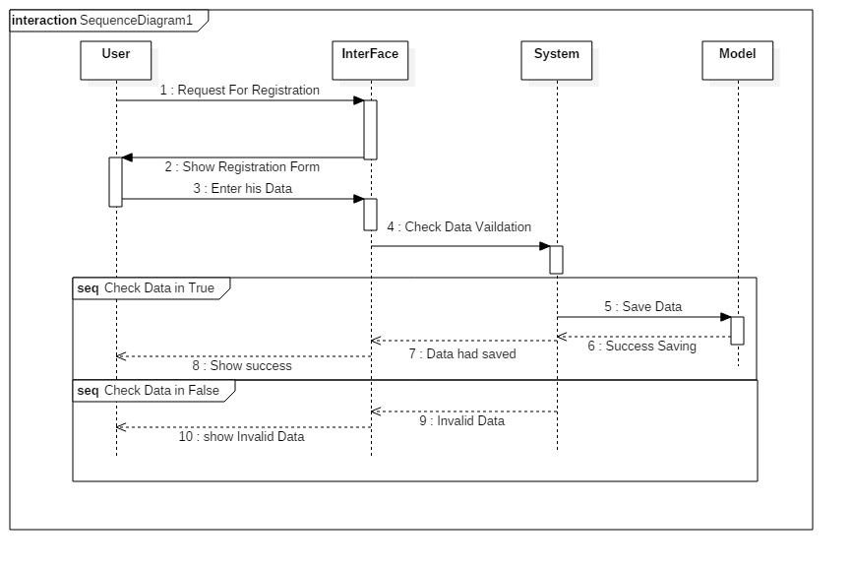

### Class - Sequence Usage Table

| **Class Name** | **Sequence Diagrams** | **Overall used methods** |
| --- | --- | --- |
| Template | 2 | GetTemplateForm()  GetTemplateName()  GetTemplateImage() |
| Type | 1, 2 | GetTemplates()  GetTemplate(String TemplateName)  GetTypeName() |
| Category | 1, 2 | GetCategoryName ()  GetAllTypes () |
| Game | 1, 2 | Create game, play Game |
| Teacher | 1, 2, 3 | Use all Setters to save data Teacher in registration  Use all Getters to login to create game to create or play game  SetSchoolName()  SetSchoolAddress() |
| Student | 1, 3 | Use all Setters to registration  Use all Getters in login to load Student data to play a game  getAchievement()  calculateAchievement() |
| User | 1, 2, 3 | Use all Setters to registration |
| Interface | 1, 2, 3 | LoadRegestrationform(),  Showmessege()  loadLoginForm ()  loadCategories ()  loadTypes ()  loadTemplets ()  ShowListtOfGames()  showTemplate()  ShowFeedback() |
| System | 1, 2, 3 | CheckDataValidation |
| Model | 1, 2, 3 | SaveDataForUserOrTeacher  CheckPrimarykey(Username )  loadCategory (categoryID)  loadTypes (typeID)  loadTemplets (TeplateID)  checkValidUser (User )  saveGameData(username)  SaveUserFeedback(username)  LoadGameInformation(Game ID)  ConnectionToDataBase() |

# Ownership Report

|  |  |
| --- | --- |
| **Item** | **Owners** |
| All team work together in this Phase | *Sameh, Emam, Roaya, Ehab* |
|  |  |